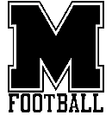**2025 MONTFORD FOOTBALL**

**COACHING & SUPPORT STAFF**

**KEITH COTTRELL**

**HEAD FOOTBALL COACH**

Coach Cottrell enters his fourth season as the head coach of the Mustangs in 2025 and also serves as the Montford Athletic Director.

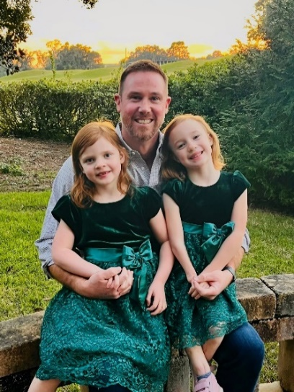After playing 3 sports in high school and earning 1st team All-Central Florida honors as a quarterback, he signed with Florida State. Following a 4-year stint at punter, he signed as a free agent with the Detroit Lions.

A graduate assistantship for Coach Bowden at Florida State developed a love for coaching and a career that has spanned 22 years. Coach Cottrell has coached at 3 high schools in Florida & South Carolina both as a Head Baseball Coach and Head Football Coach. As a teacher, he spent most of his career teaching American Government & Economics.

Off the field, he is the proud father of twin girls, Merritt & Grace. He enjoys cooking, exercising & woodworking. He values faith, friends and every moment he can spend with his daughters.

**DAYNE READ**

DEFENSIVE COORDINATOR/SECONDARY

Coach Read begins his 2nd season on the Montford Staff and moves into the Defensive Coordinator role and coaching the secondary. He has also coaches running backs for the Mustangs.

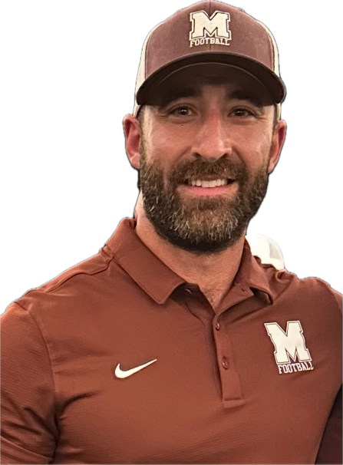 A two sport all state stand out at Tallahassee’s North Florida Christian, he was the 1A State Player of the Year and 3 time All- Big Bend selection, playing on both sides of the ball. Upon graduation, he turned down several high profile football offers to play baseball at powerhouse Chipola Junior College. After Chipola , he played 3 years in the Cincinnati Reds organization, reaching as high as the Triple-A level.

An accomplished baseball coach, Coach Read is an executive in a non-profit business. Off the field, he enjoys hunting, fishing, fitness and being a father to his son, DJ.

**BERT GIVENS**

OFFENSIVE COORDINATOR/QUARTERBACKS & RECEIVERS

Coach Givens will enter his 3rd season on the Montford Staff in 2025. He will coordinate the offense, coach quarterbacks and receivers.

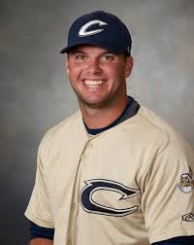 A 4 year starter at both quarterback and shortstop at Tallahassee Chiles, Coach Givens was an All-Big Bend player and an elite athlete in the north Florida sports landscape. A tough, savvy signal caller, he owns 13 offensive records on the gridiron for the Timberwolves. After leading his team to the state finals in baseball, Coach Givens played baseball at both Chipola Junior College and Troy University. Coach Givens comes from a coaching family, where his father Steve was the Head Baseball Coach at North Florida Community College and Athletic Director at Chipola and his sister, Rachel, was a cross country runner at Auburn.

Since graduating from Florida State with a law degree, he has served his community as a prosecutor for the State’s Attorneys office in both Leon and Jefferson Counties.

**RAY KNIGHT**

OFFENSIVE LINE

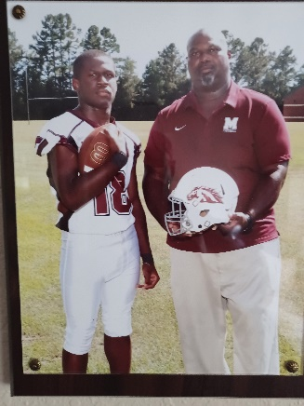Coach Ray Knight begins his 3rd season on staff for the Mustangs where he leads the most important group on the entire field, the offensive line.

A former FAMU Rattler player, Coach Knight has a great knack for getting 5 players to play in unison, often time with athletes who have never played before. He is largely responsible for Montford’s 2024 success and rushing game prowess. Coach Knight will have the unenviable task of breaking 5 new starters this year. Beloved by his players for his loyalty and humor, Coach Knight is a key piece of the Montford program.

As the owner/operator of his business, a Knightly Shine, he can be found off the field supporting the athletic pursuits of his daughter Kimberly and son Sean.

**CODY LEDFORD**

DEFENSIVE LINE/RUNNING BACKS

Coach Cody Ledford is in his 1st season with the Mustangs in 2025. He will lead the defensive line and oversee the running backs on offense.

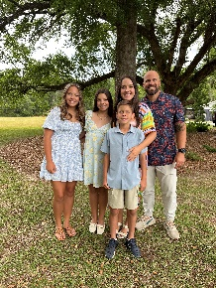 A 4 year starter at North Florida Christian, he still holds the school record for tackles with over 500. He was named the 1A Florida Dairy Farmer’s Player of the Year as a senior. He signed with Tulane University after high school and led the Green Wave until a knee injury ended his career.

A logistics executive in construction, he is the proud father of 2 current Mustang athletes, volleyballs Aniston and Ila and future soccer player, Lennox.

**TALLON CAMPBELL**

LINEBACKERS

Coach Campbell begins his 4th season coaching and 2nd season with Montford in 2025, where he will be responsible for the linebackers.

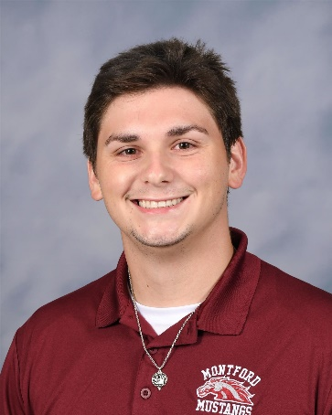 A graduate of Cheraw High in South Carolina, he was a 4-year starter at linebacker for Limestone College where he earned a degree in Information Security Systems and a Masters in Health Informatics. On campus at Montford, he teaches 6 classes of

Off the field, Coach Campbell can be found spending time with his wife, Madison.

**SUPPORT STAFF**

**FRED THOMPSON**

VIDEO COORDINATOR

Coach Fred Thompson oversees all aspects of game film acquisition for the program. This invaluable job is done as a volunteer from a generous fellow coach.

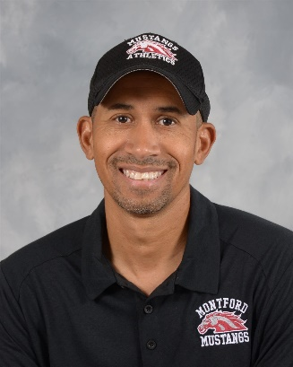 A 17 year veteran of the Montford faculty, he has served as the head coach of 4 sports during his time as a Mustang, including 4 county championships as the head football coach. Currently he serves as the Head Boys Basketball coach. He is an incredible resource and support to Coach Cottrell with his experience and care for students.

A well-respected member of the Big Bend coaching community, Coach Thompson is a college and high school basketball official in the free time he finds. He has one son, future Mustang Trey.

**DAVE WESTBERRY**

PUBLIC ADDRESS ANNOUNCER

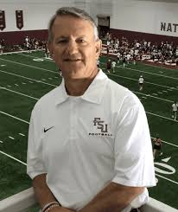Dave Westberry will be in his 4th season as the public address announcer for Montford in 2025. In his other job, he will be in his 41st season as the Doak Campbell Voice of the Florida State University Marching Chiefs.

Dave, alongside his spotter and wife Janey, brings a professional voice to the games, making the game experience better and allowing parents to hear their players names. The Westberry’s serve our boys in selfless and unseen ways, coming alongside in support of the mission to grow boys into young men through football.

**Dr. RAYMOND COTTRELL**

TEAM DOCTOR

Dr. Raymond Cottrell is in his 4th year as the team doctor for the Mustangs. A physician for 43 years in both Orlando and Tallahassee, he has been the team doctor for 2 different high schools as well as Team Specialist for Florida State Football.

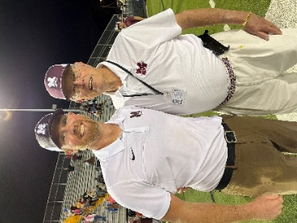A long time Seminole Athletics supporter, you can find “Doc” at a Noles game, being involved in his church, playing golf or spoiling his granddaughters beyond what is reasonable.